# Department of Computing

**Name Syed Muhammad Umer Zeeshan**

**Reg. # 132499**

**CS213: Advanced Programming**

**Class: BSCS – 5C**

# Lab 3: Getting started with R and building our first R application

**CLO3: Develop applications and tools using various frameworks**

**Date: September 29, 2017**

# Time: Friday (14:00 – 17:00)

# Instructor: Shamyl Bin Mansoor

## Use the mtcars data set to plot different graphs in order to convince a buyer which is the best car to buy. Assume some kind of criteria that the car is interested in e.g. Young buyer with interest in speed, or an executive thinking of buying a luxury sedan etc.

Mileage vs HP graph

**Assuming a Young buyer**

library(ggplot2)

data(mtcars)

attach(mtcars)

plot(hp, mpg, main = "Mileage vs HP", xlab = "HP", ylab = "Mileage",

pch = 10, col = "violet")

text(hp, mpg, row.names(mtcars), cex = 0.6, pos = 4, col = "cyan")

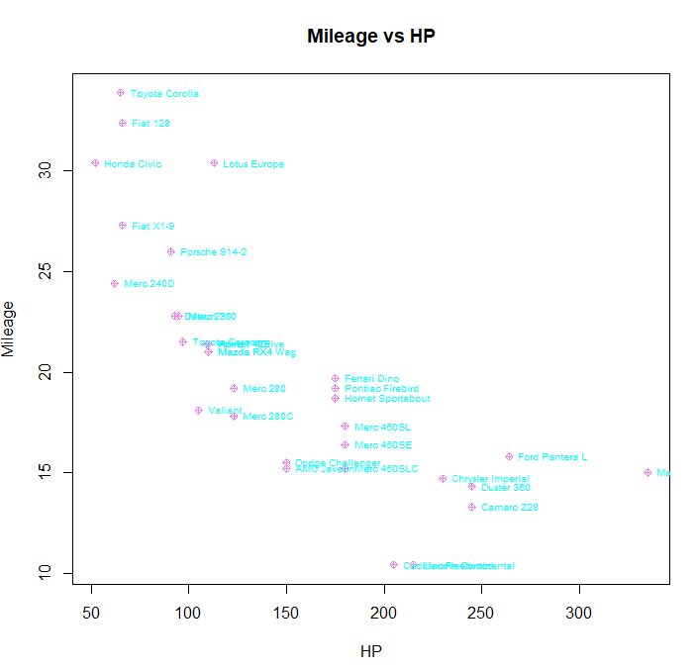

Displacement vs Mileage graph

**Assuming a buyer who is interested in a fuel efficient car**

## Source Code

library(ggplot2)

data(mtcars)

attach(mtcars)

plot(mpg, disp, main = "Displacement vs Mileage", xlab = "Milage", ylab = "Displacement",

     pch = 15, col = "cyan")

text(mpg, disp, row.names(mtcars), cex = 0.6, pos = 4, col = "pink")

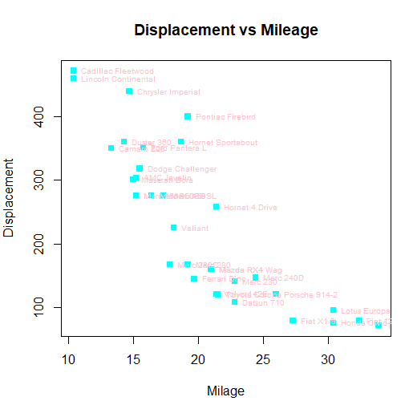

Weight vs Horsepower

**Assuming a buyer who is interested in a luxury car**

## Source Code

library(ggplot2)

data(mtcars)

attach(mtcars)

plot(wt, hp, main = "Weight vs Horsepower", xlab = "Weight", ylab = "horsepower",

     pch = 15, col = "cyan")

text(wt, hp, row.names(mtcars), cex = 0.6, pos = 4, col = "pink")

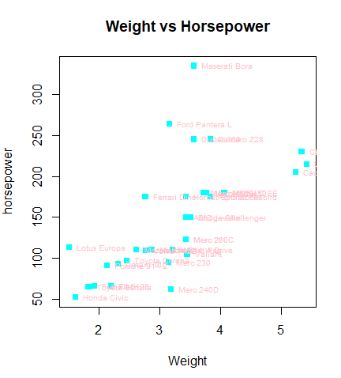

Weight vs Displacement

## Source Code

library(ggplot2)

mtcars

attach(mtcars)

plot(disp, wt, main = "Weight vs Displacement", xlab = "Displacement", ylab = "Weight",

     pch = 15, col = "cyan")

text(disp, wt, row.names(mtcars), cex = 0.6, pos = 4, col = "pink")

